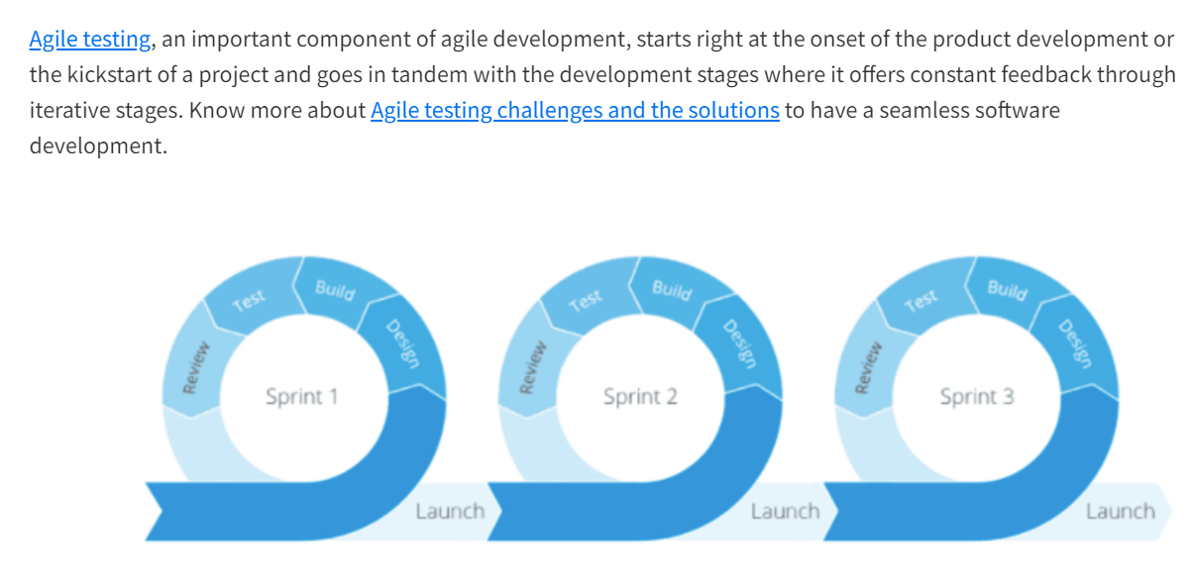

# Command line Basics

Change Directory, directory list, present working directory

Windows – cd & dir

Macos/Linux – pwd & ls & cd & clear

One requirement for each deployment.

To any concept or terms just use w’s what, why and where, How,

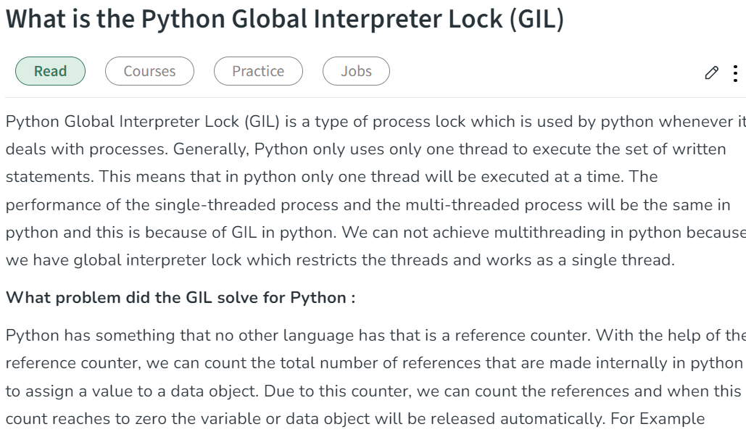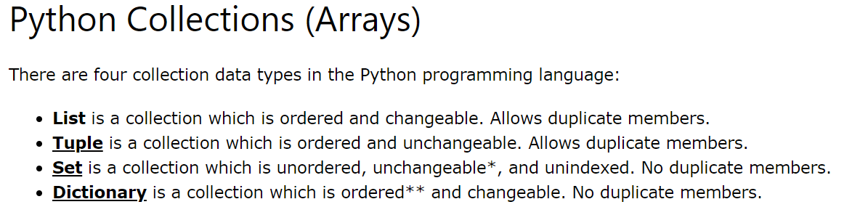

**List** and **Tuple** are the collection data types, both data types are used to store the more items/collection of items in single variable. **List** offers storing, updating, removing, and retrieving element from the collection. Where **Tuple** just offers storing and retrieving the items because tuple is unchangeable.

**Actuators and Generators:**

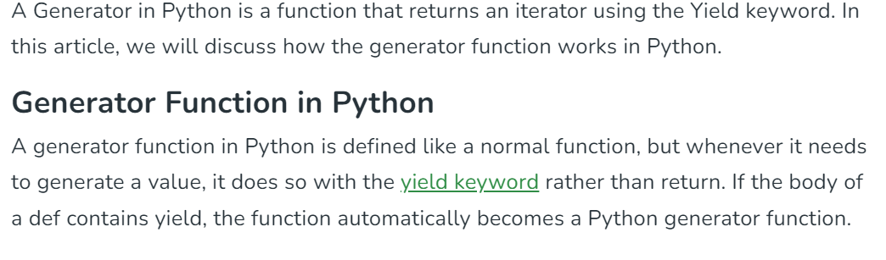

Python Generator functions return a generator object that is iterable, i.e., can be used as an [Iterator](https://www.geeksforgeeks.org/iterators-in-python/). Generator objects are used either by calling the next method of the generator object or using the generator object in a “for in” loop. We can simply retrieve [next() function](https://www.geeksforgeeks.org/python-next-method/).

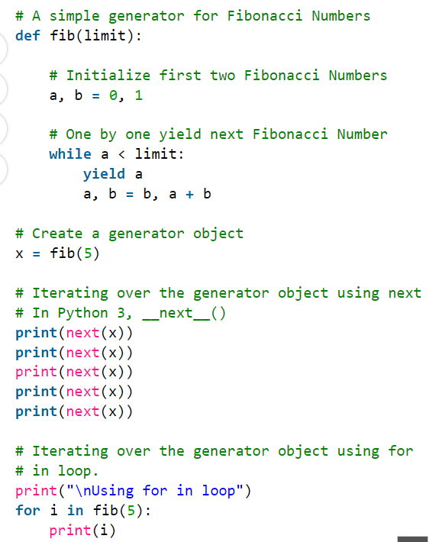

Actuator endpoints help us monitor our services. By using actuators, we can gain a lot of information about what’s going on.

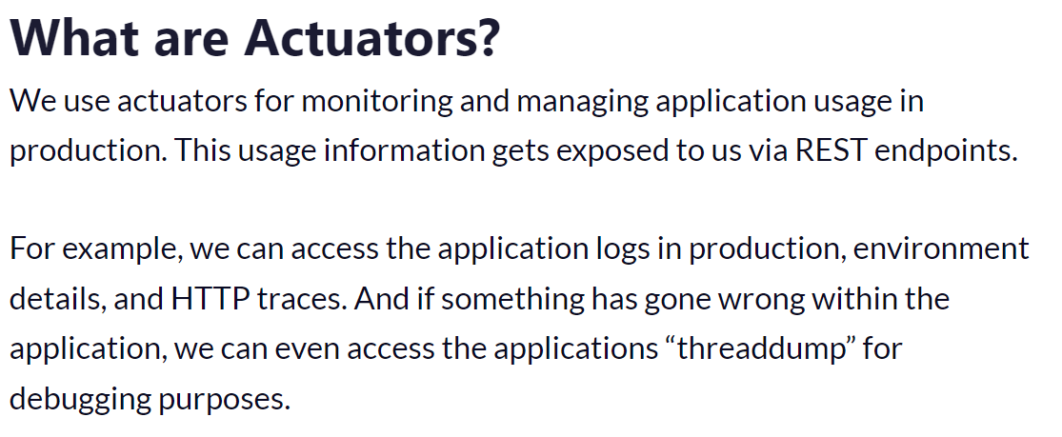

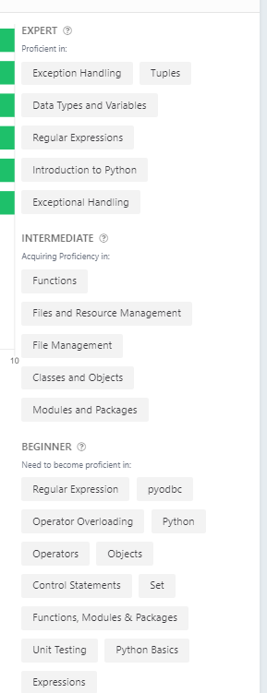

# Introduction

## Python Keywords and Identifiers

Keywords are predefined, reserved words used in Python programming that have special meanings to the compiler.

We cannot use a keyword as a variable name, function name, or any other identifier. They are used to define the syntax and structure of the Python language.

All the keywords except True, False and None are in lowercase and they must be written as they are. The list of all the keywords is given below.

## Python Flow control

If.. else, for and while loop, break and continue;

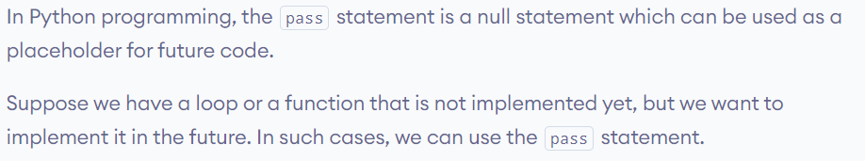

## Type conversion

Int(string_var) or str(inta-var)

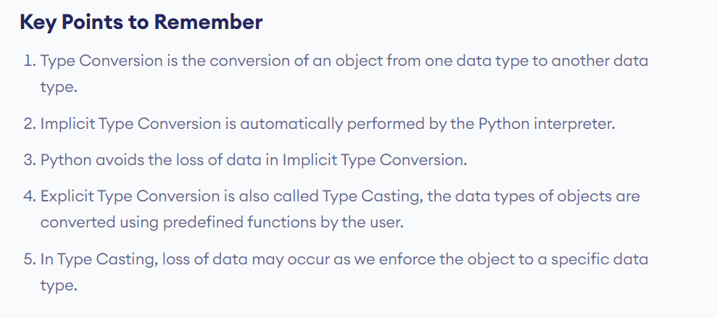

Every Programming Language starts with and developed in the scope of >

* Object Oriented Programming
* Object and Data Structures
* Methods and Functions
* Errors and Exception handling
* Control Flow Statements

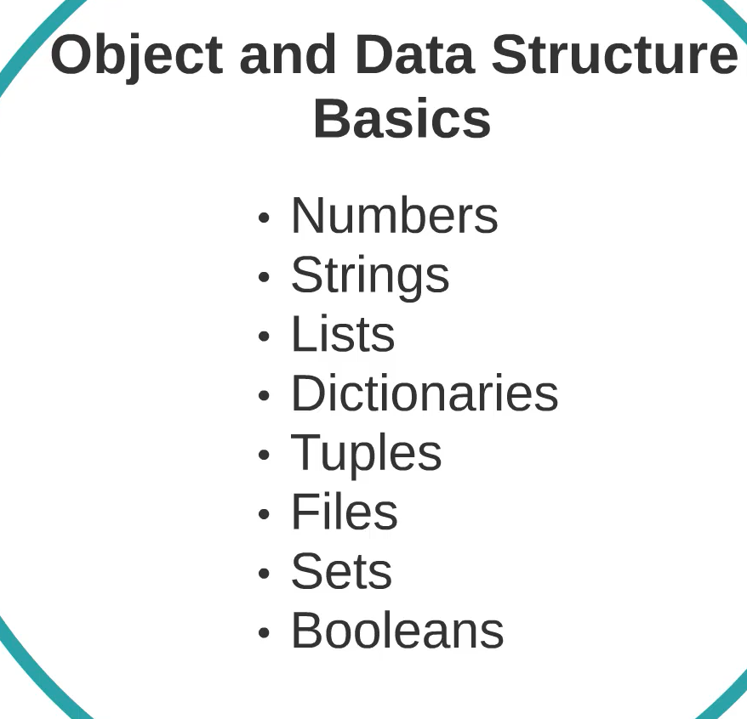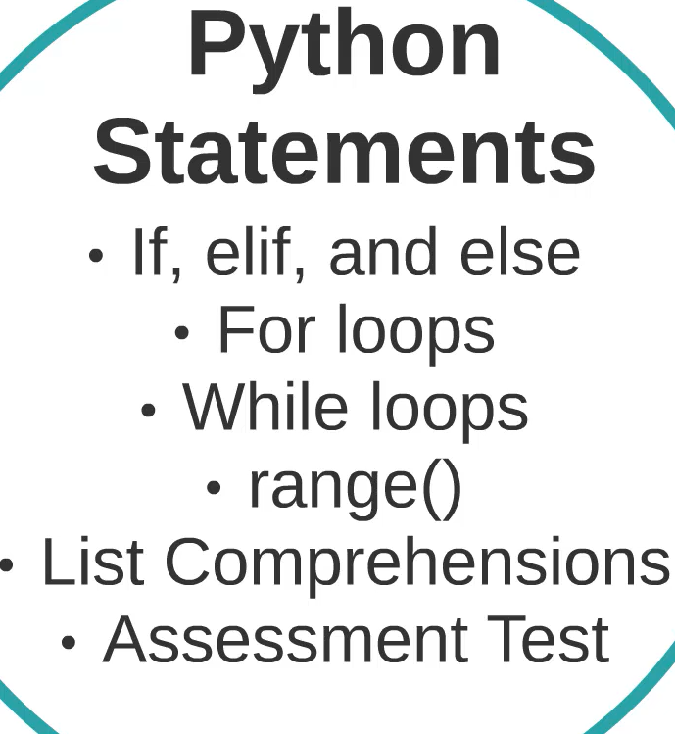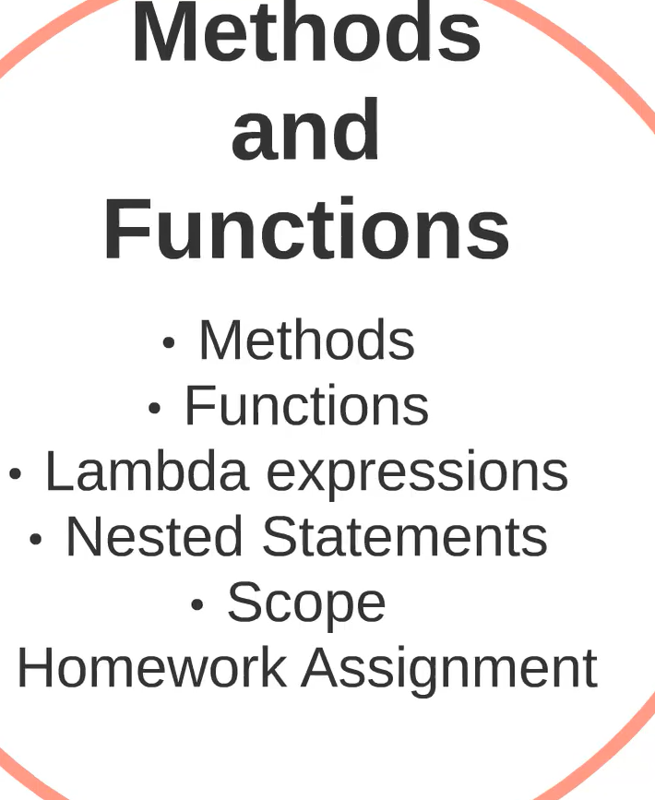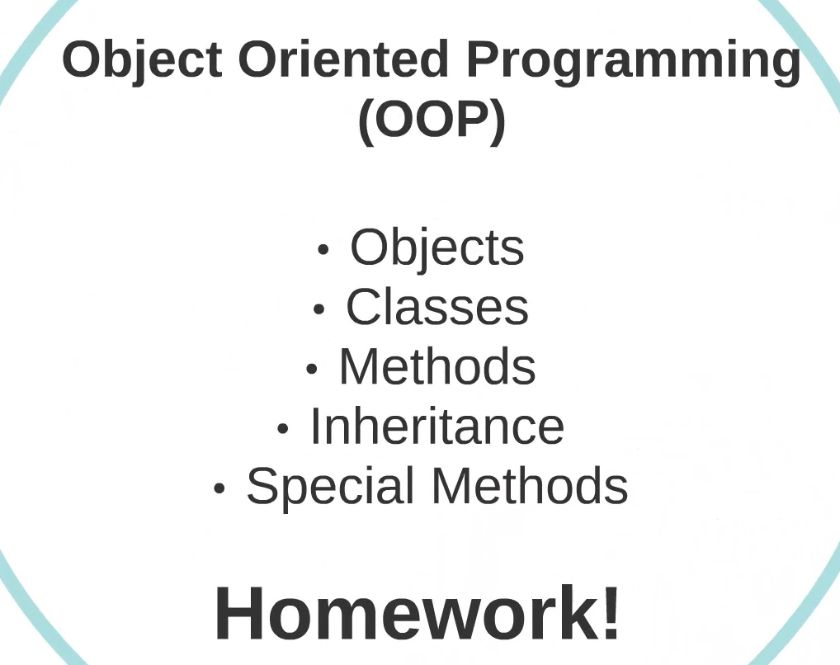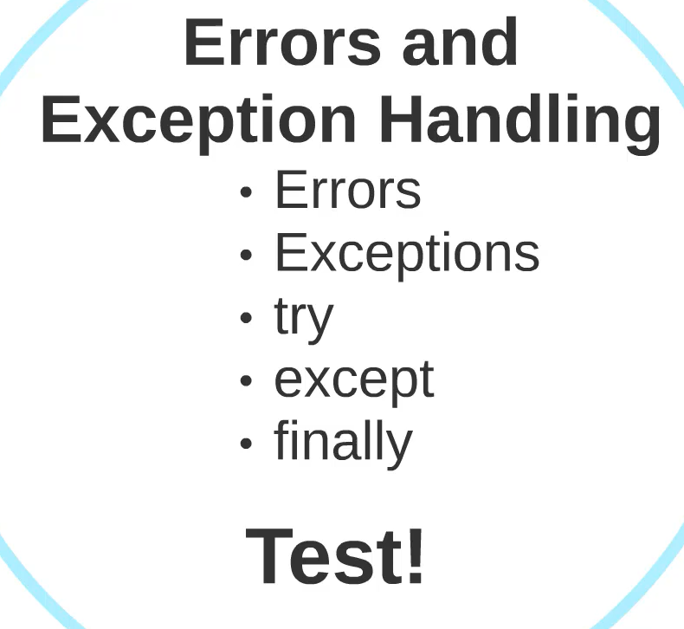

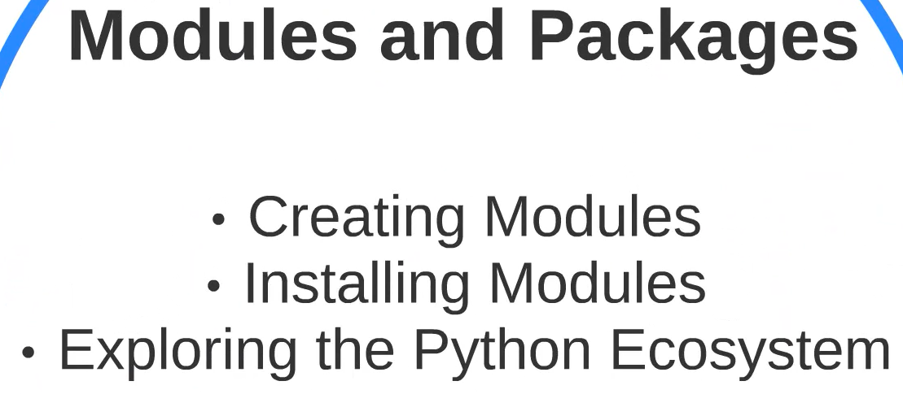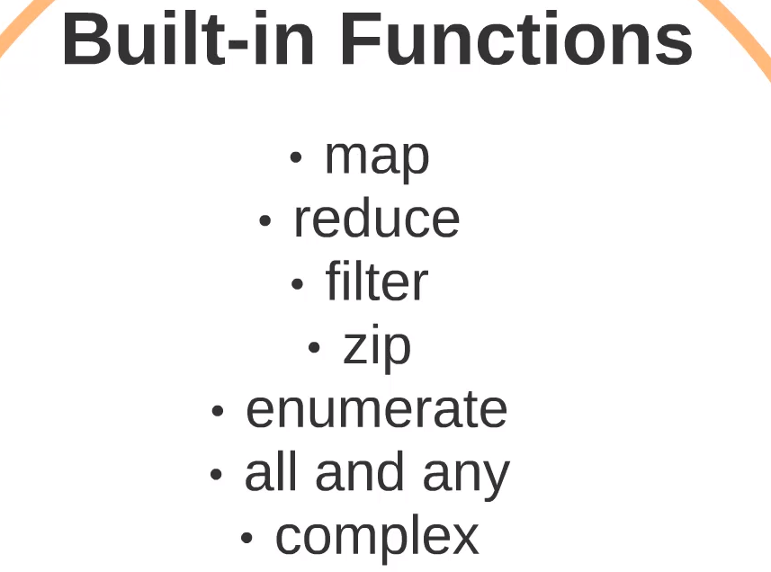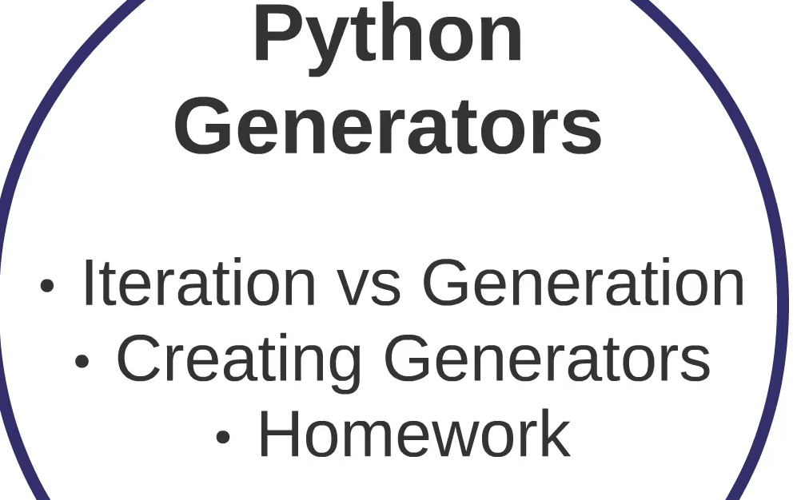

# Python Datatypes and Data Structures

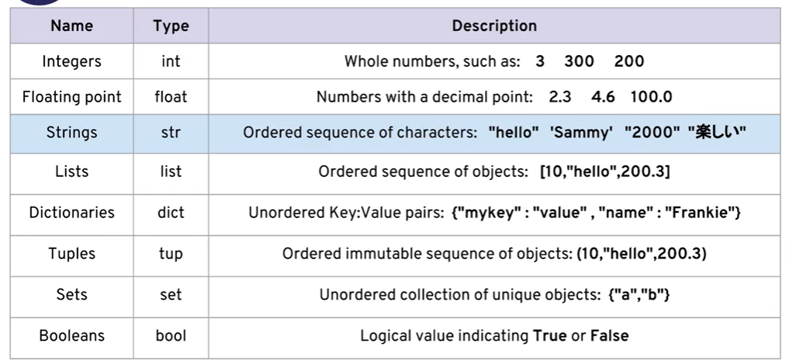

Python does not have a separate character type. It considers as string data type.

Python is Dynamically typed, use **type()** to find the data type of an variable. Not like other statically typed languages.

\n – new line & \t tab space

Slicing and Indexing in strings

Chars in string can access by indexing str[0] – features in java script and python

Negative indexing also allowed in python str[n-1]

***Slicing – str[start:stop:stop]***

Start at index

Stop – skips the index char -jumps

Stop – end the slicing

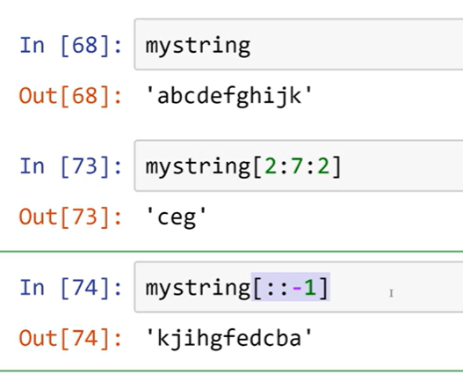

Immutable , because strings are more than variable data type not mutable by indexing -Objects just reference the same address. If changes in string it stored in new address.

str[1] = ‘q’; the 1 position won’t changes to q.

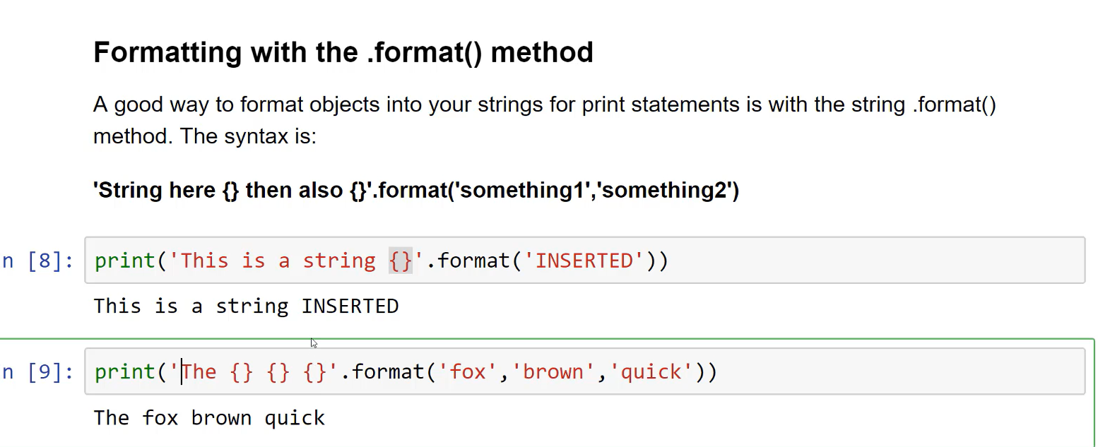

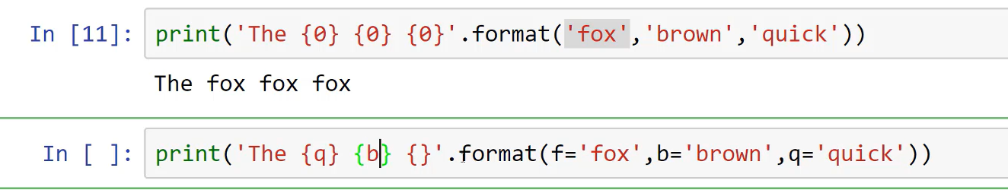

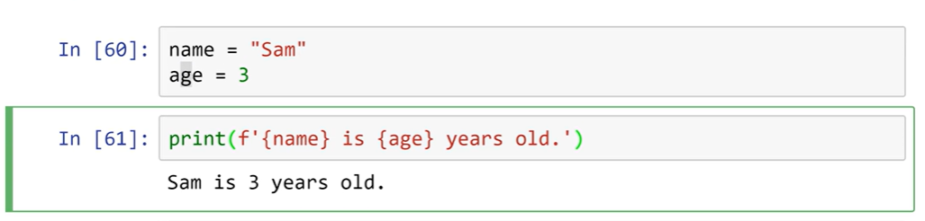

## List in Python

For String we seen Indexing, Slicing, and formatting.

Same Slicing and indexing works for lists as same as strings

append – is used to push an element to list at last index.

pop- is used to remove an element from last index, can be pass the index to pop to remove target index.

sort() – is used to sort an list.

reverse()- to reverse list.

## Dictionaries in Python

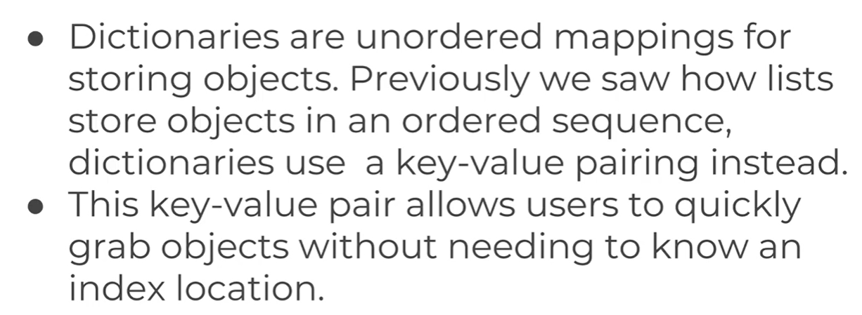

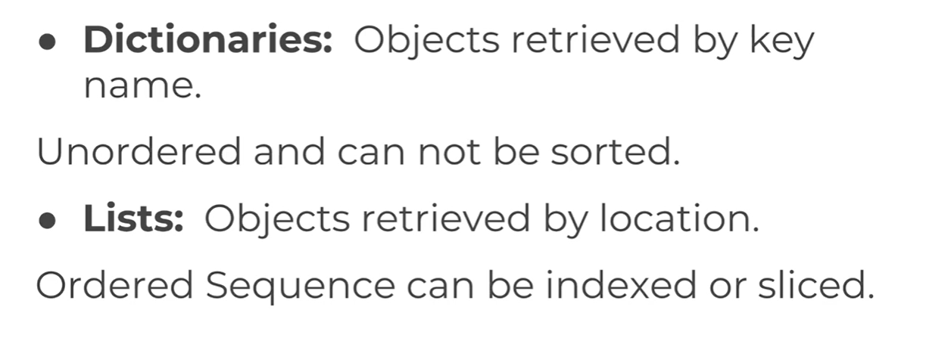

Formed with {key: value}, Uses key in index to retrieve.

Dictionaries are mutable and won’t follows order of sequence.

## Tuple in Python

Similar to list but immutable – tuple =(“d”,”dwsd”)

count() – is used to count the number of occurrences a passed value in tuple.

Index() – to get the index of passed value

## Sets in Python

myset = set() – it won’t store duplicate values.

add – is used to add value to the in ordered set.

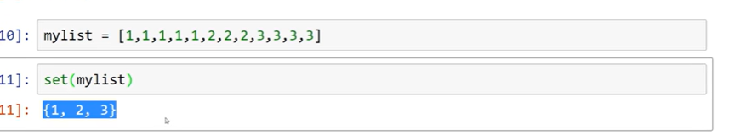

Boolean True or False , if an variable is none it conditional check is False.

## Files in Python

write open read seek(0) close()

**open()** – to open the file and based on mode mentioned the file operation is permitted to do

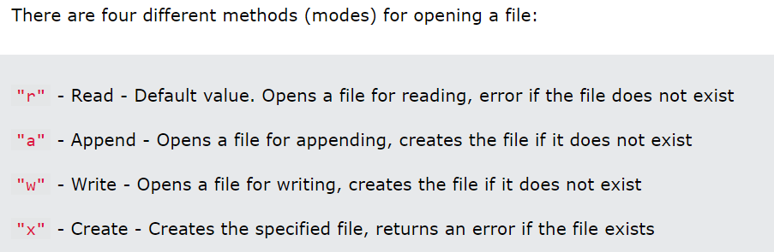

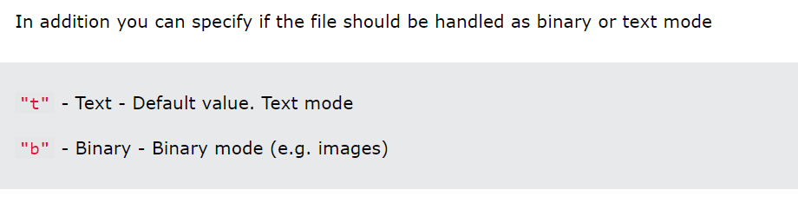

Open File:

f = open("demofile.txt", "rt")

Read File:

print(f.read())

to read only few parts of file - print(f.read(**5**))

Read Lines method returns the data in line by line

f = open("demofile.txt", "r")  
print(f.readline())

The readlines() method returns a list containing each line in the file as a list item.

f = open("demofile.txt", "r")  
print(f.readlines(33))

f.close()

to remove an file:

import os  
os.remove("demofile.txt")

To write in file use mode “a” or “w”

To write to an existing file, you must add a parameter to the open() function:

"a" - Append - will append to the end of the file - put

"w" - Write - will overwrite any existing content - post

f = open("demofile2.txt", "a")  
f.write("Now the file has more content!")  
f.close()   
  
#open and read the file after the appending:  
f = open("demofile2.txt", "r")  
print(f.read())

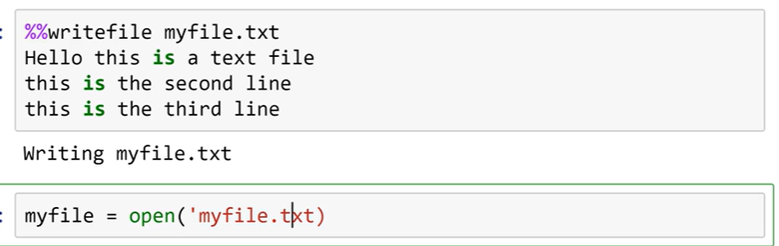

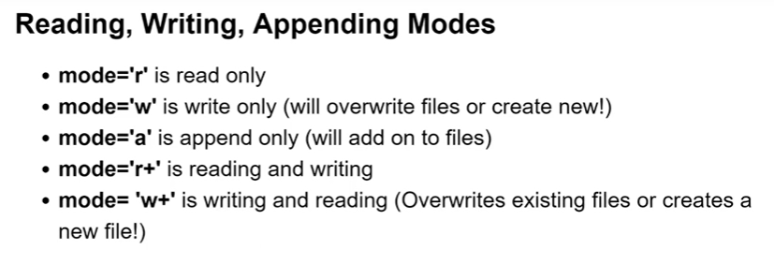

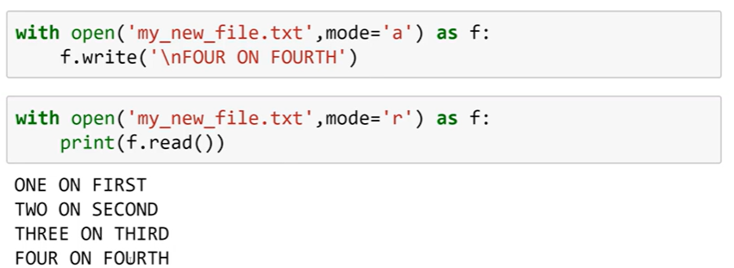

## Control flow statements in Python

Control flow mainly depends on indentation.

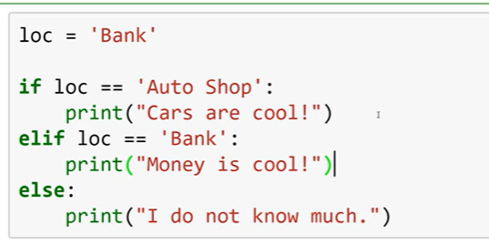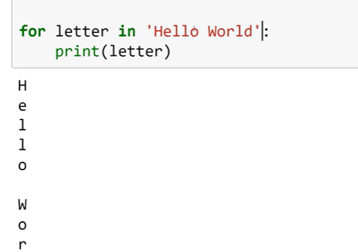

Using for loops iterating through the tuple, dictionaries, sets , and list is possible **simple for i in collection**

Where for the dictionaries can use **for i in d.values(): OR for i in d.keys():**

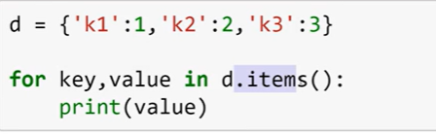

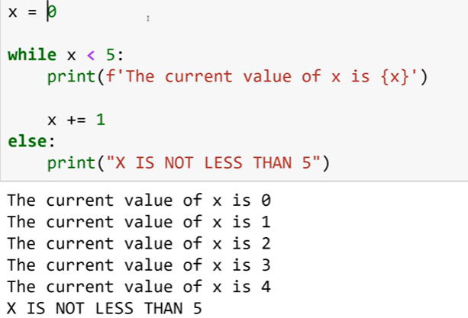

In loops **break, continue, and pass** can be used

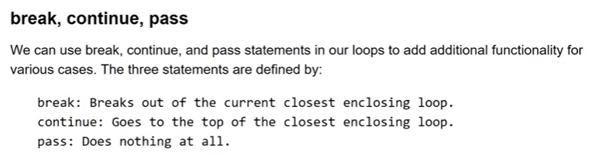

## Use full operators

**range,**

**enumerate returns item as tuple**

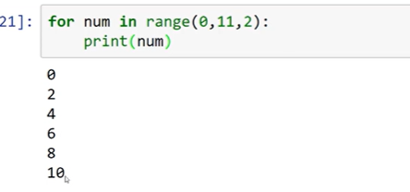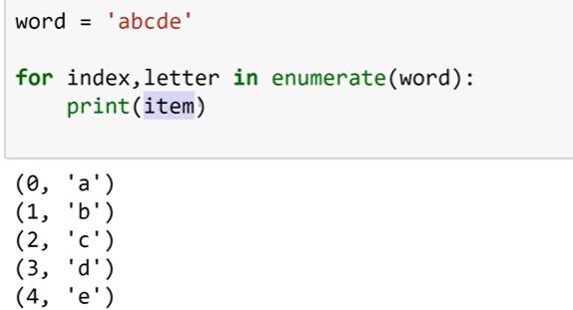

**zip** is used return the different data structures into tuple when iterating. FIRST INDEX elements are returns as each tuple

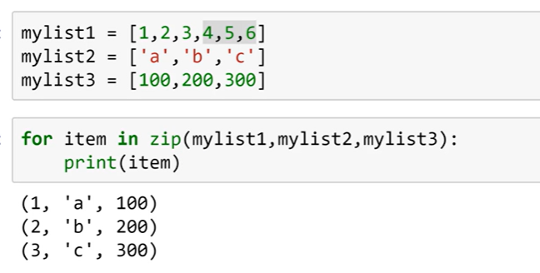

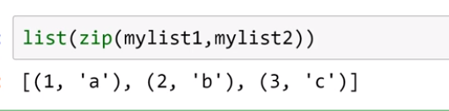

in can be used to check whether the value or key present in collection

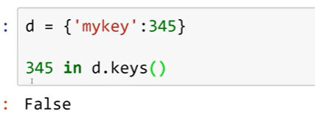

And also max and min can be used in collection to get min nd max values

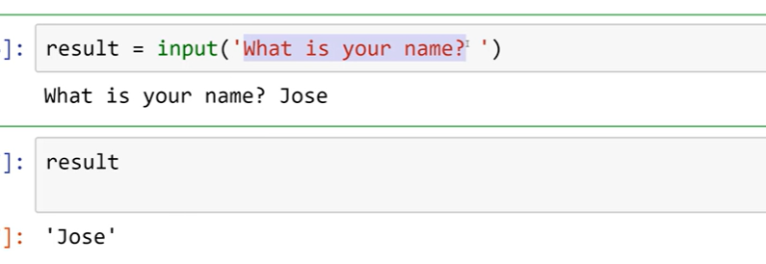

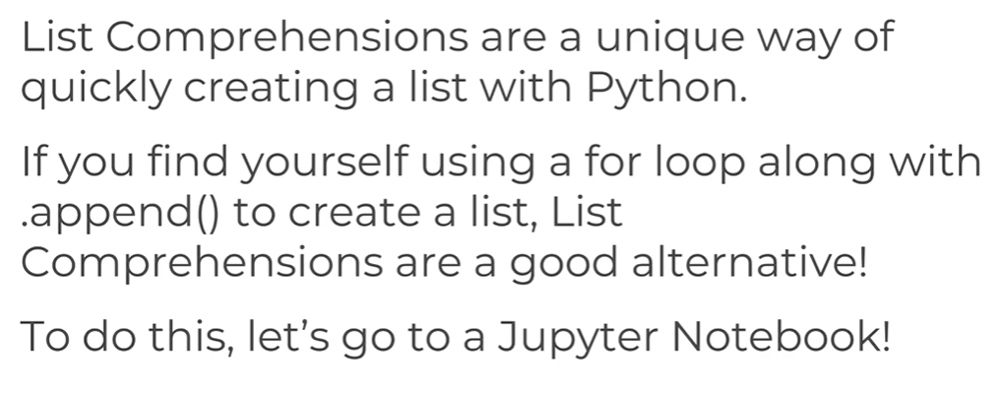

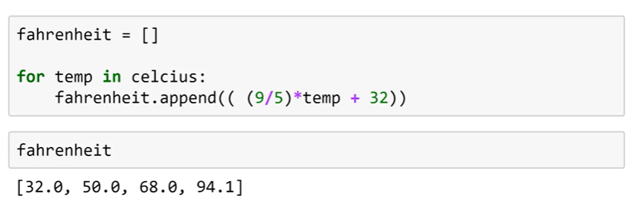

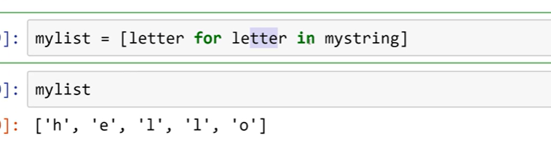

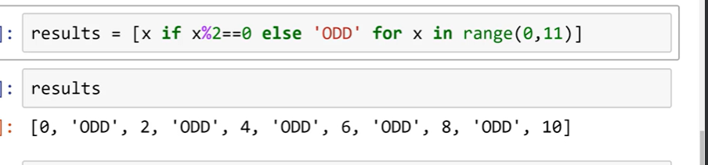

# Methods and Functions in Python

Methods are built-in library functions to speed-up the development.

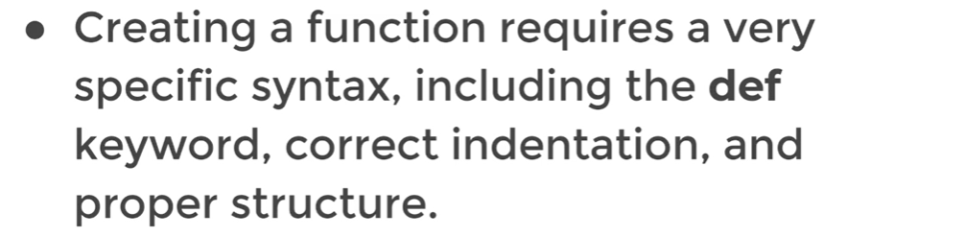

Functions can be called and assign to another variables like , when used the () brackets function will be called , when just only function mentioned it means can access the function.

## *args and *kwargs

Placing args as parameter to the function, it takes as many as parameters when it’s calling.

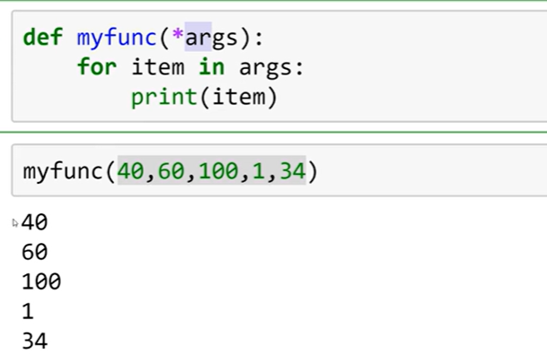

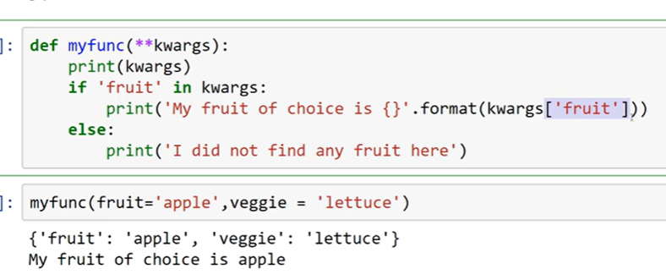

kwargs returns the dictionary as liswt. And allows to pass arguments as key and value.

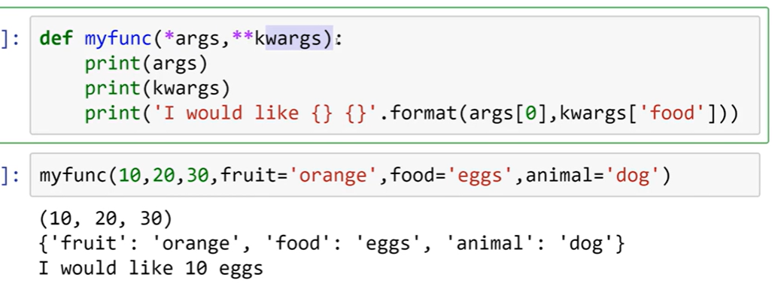

*args is list where **kwargs is dictionary

# **Lambda Expressions – Map and Filter**

map(function, list)

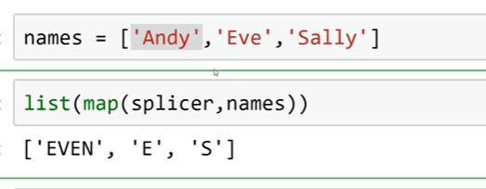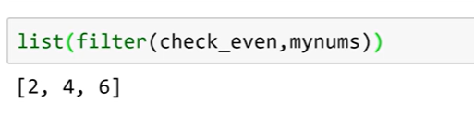

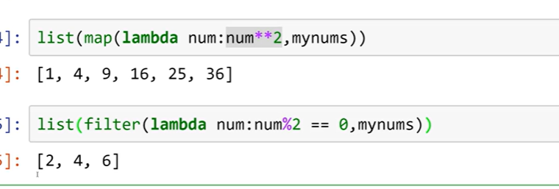

# **Nested and Scopes**

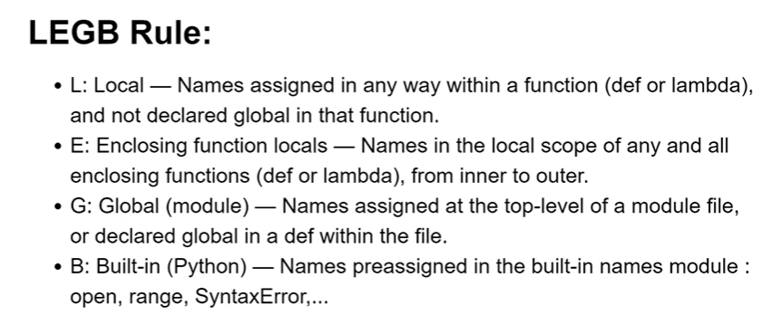

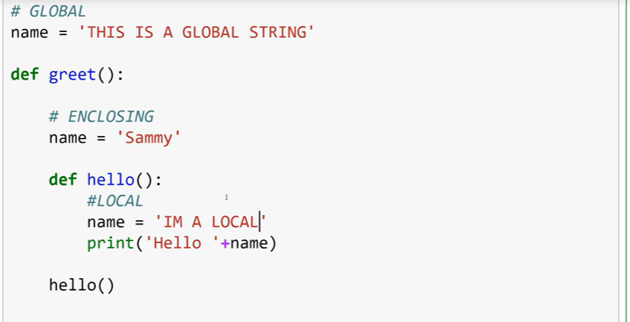

# **Object Oriented Programming in Python**

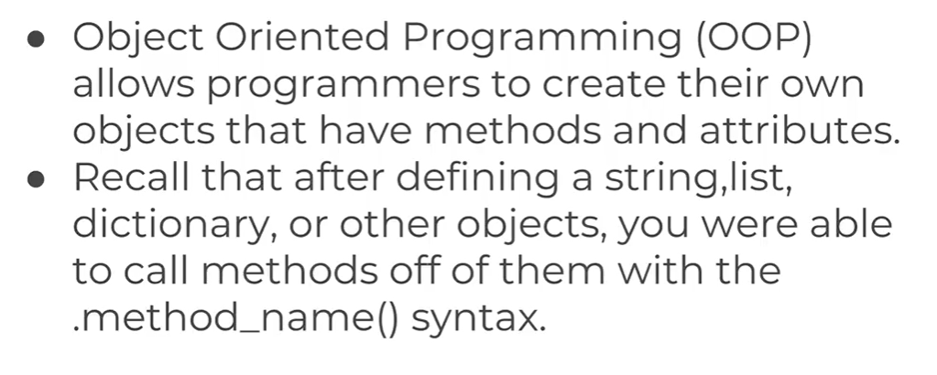

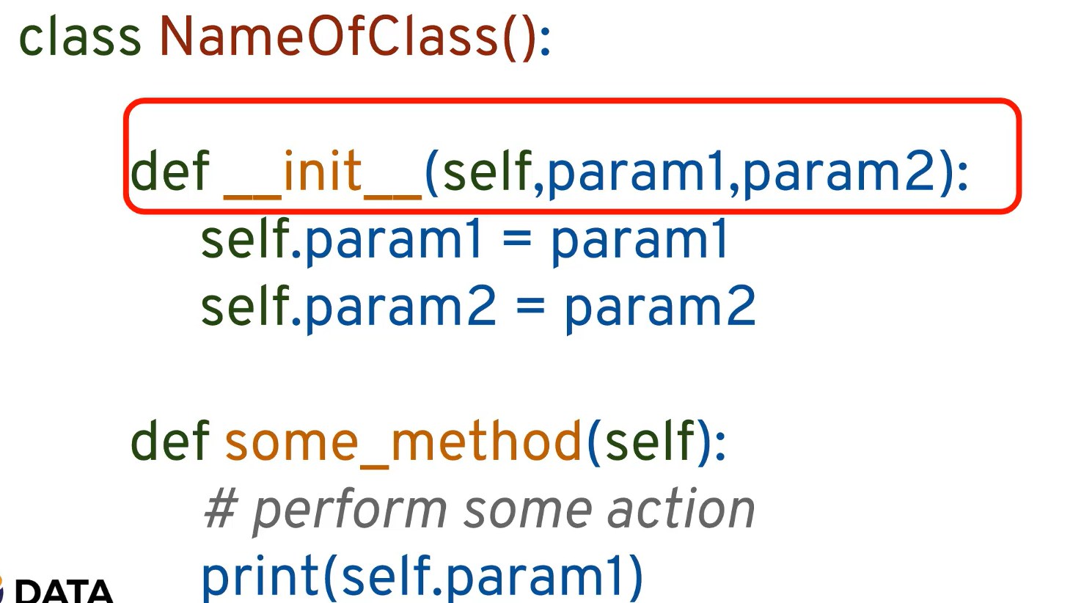

init function a object initializer and constructs the object when object is called with the defined attributes.

TO access the Attributes in side the class self is used to do it as self is reference of the current object as this in JAVA.

## Inheritance

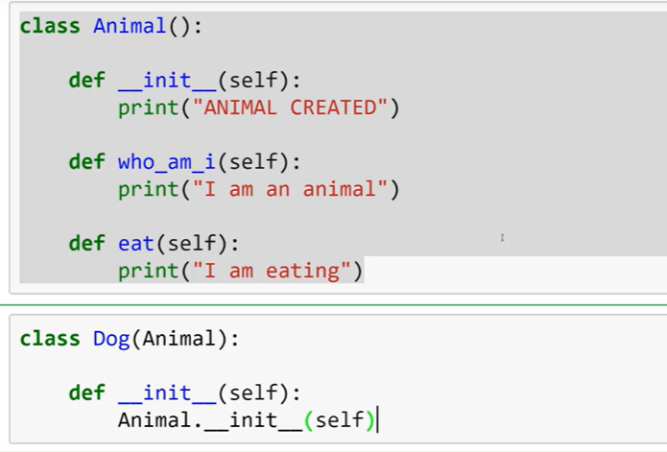 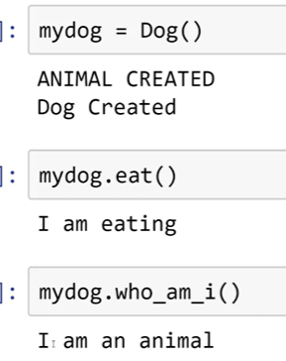

## **Polymorphism**

Method overriding – the execution of method depends on the instance created at the time of object initialization.

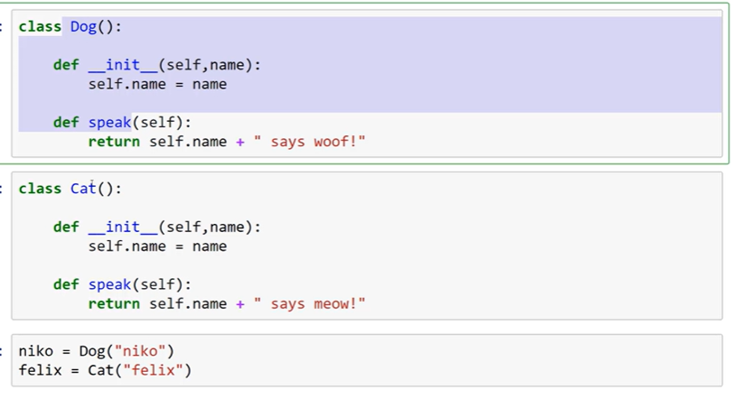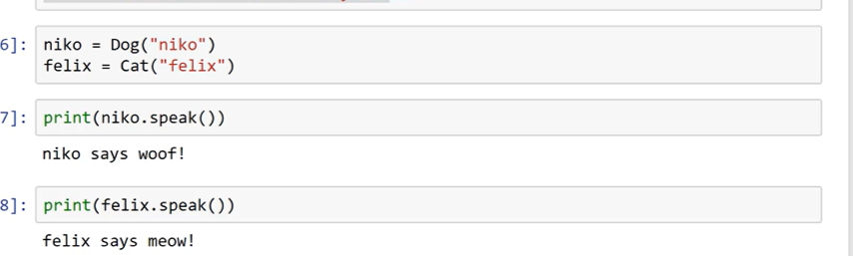

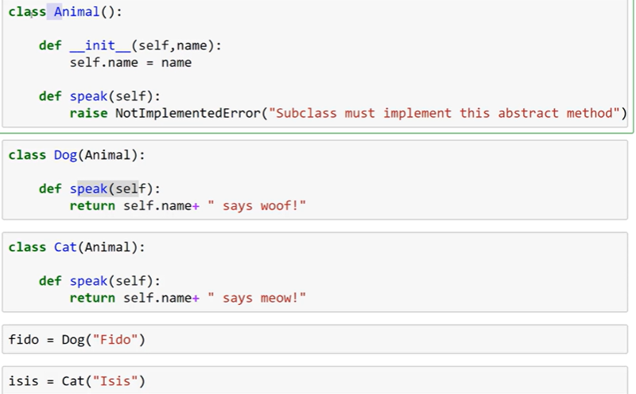

## **Special Functions – Operator overloading**

Operator overloading in Python allows you to define or redefine the behaviour of operators for user-defined data types. This means you can make objects of your class work with Python's built-in operators like **+**, **-**, **\***, **/**, and many others.

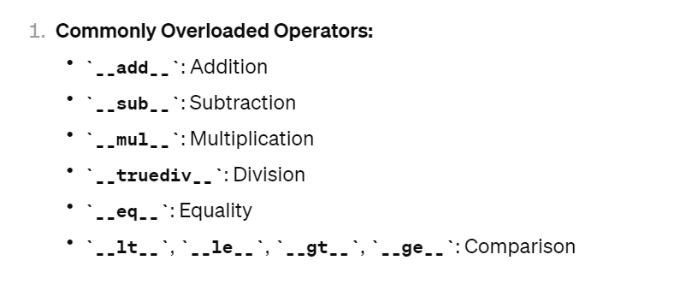

The use defined objects won’t have the built in functions, so these special functions are used.

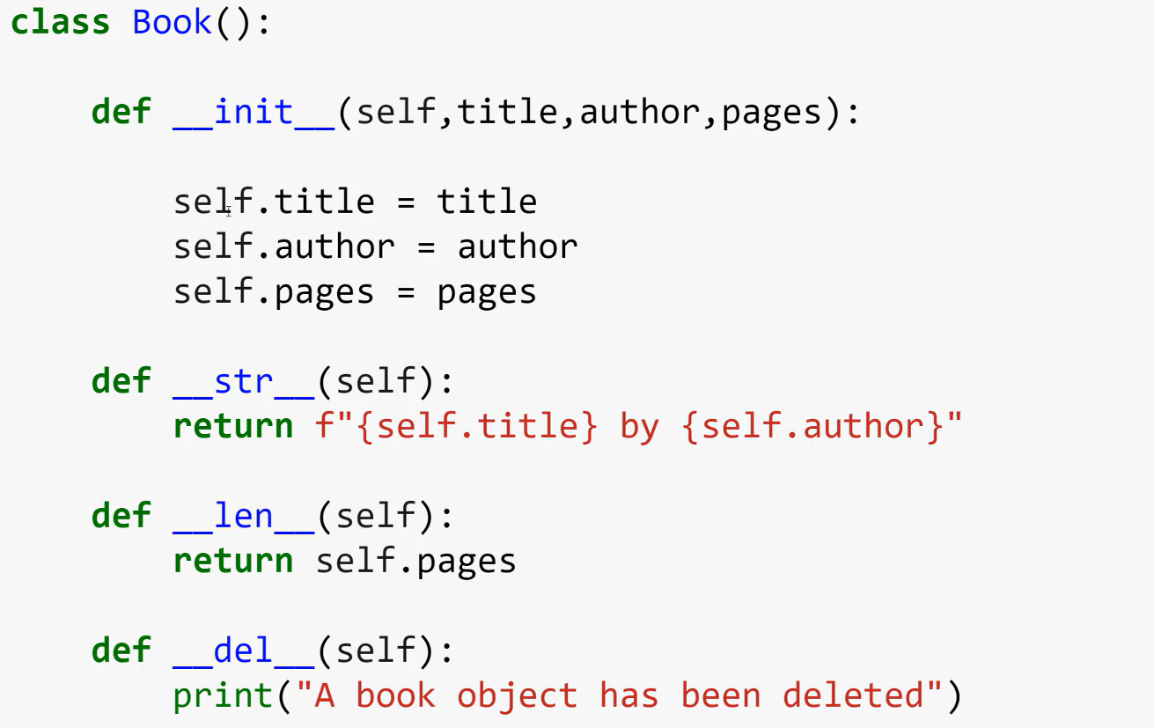

Python Modules and Packages are managed and installed from PyPi pip

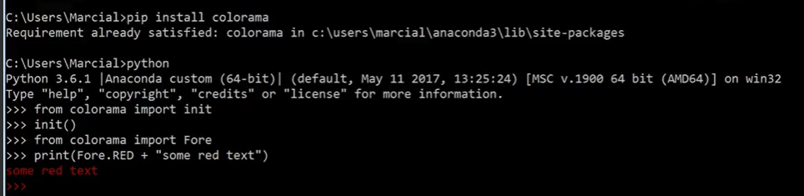

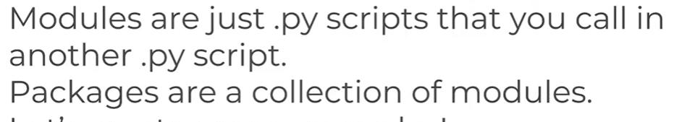

__init__.py tells a directory is a package.

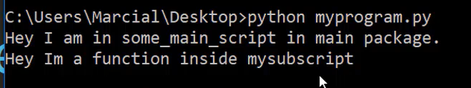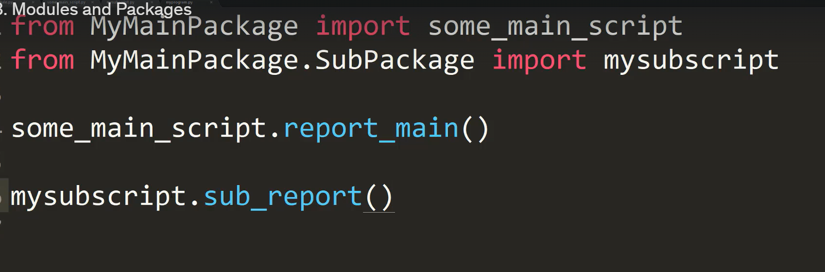

Two differentiated between the call by imported or directly called the below example well explains

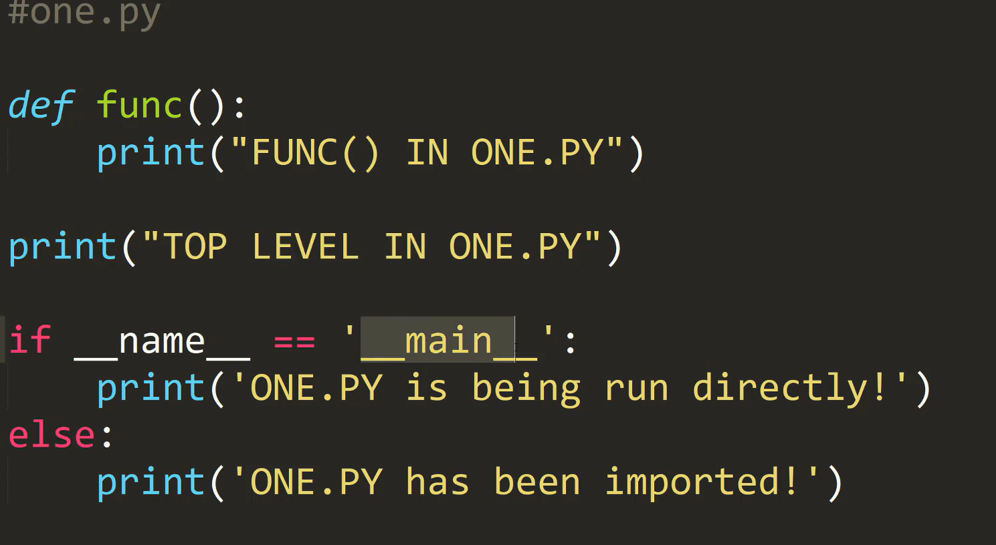 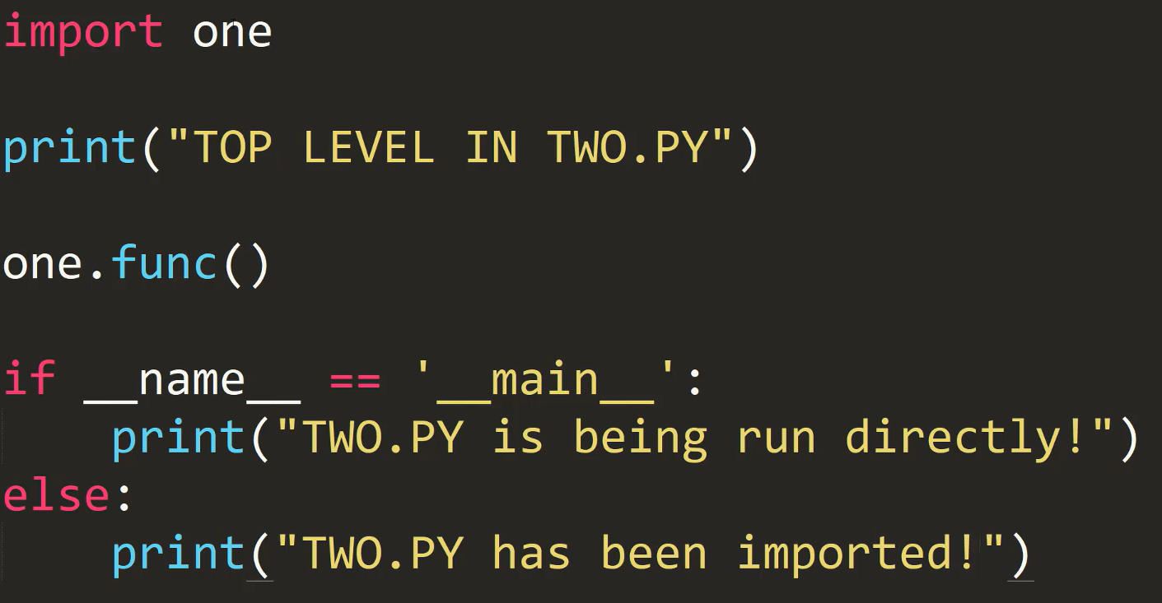

So this way executing the functions fro various purposes

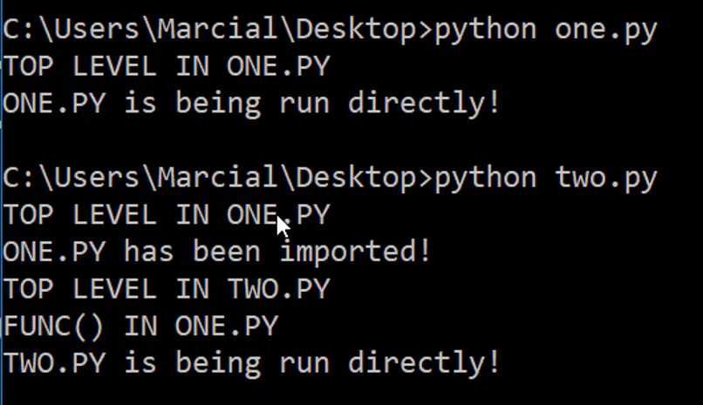

# **Errors and Errors Handling in python**

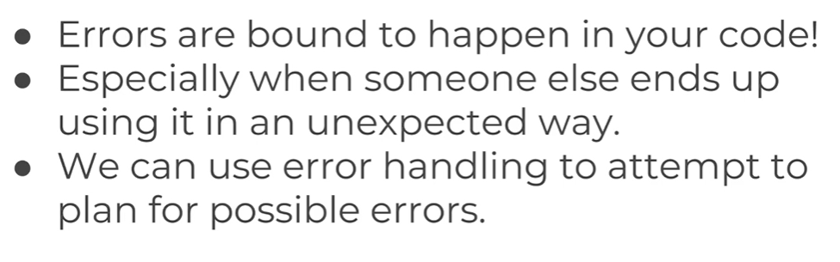

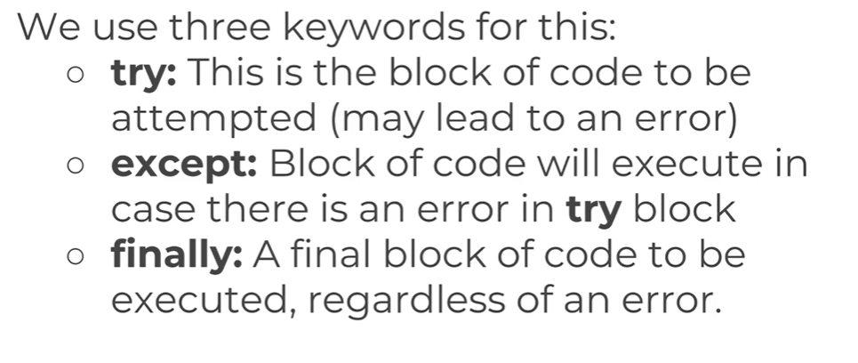

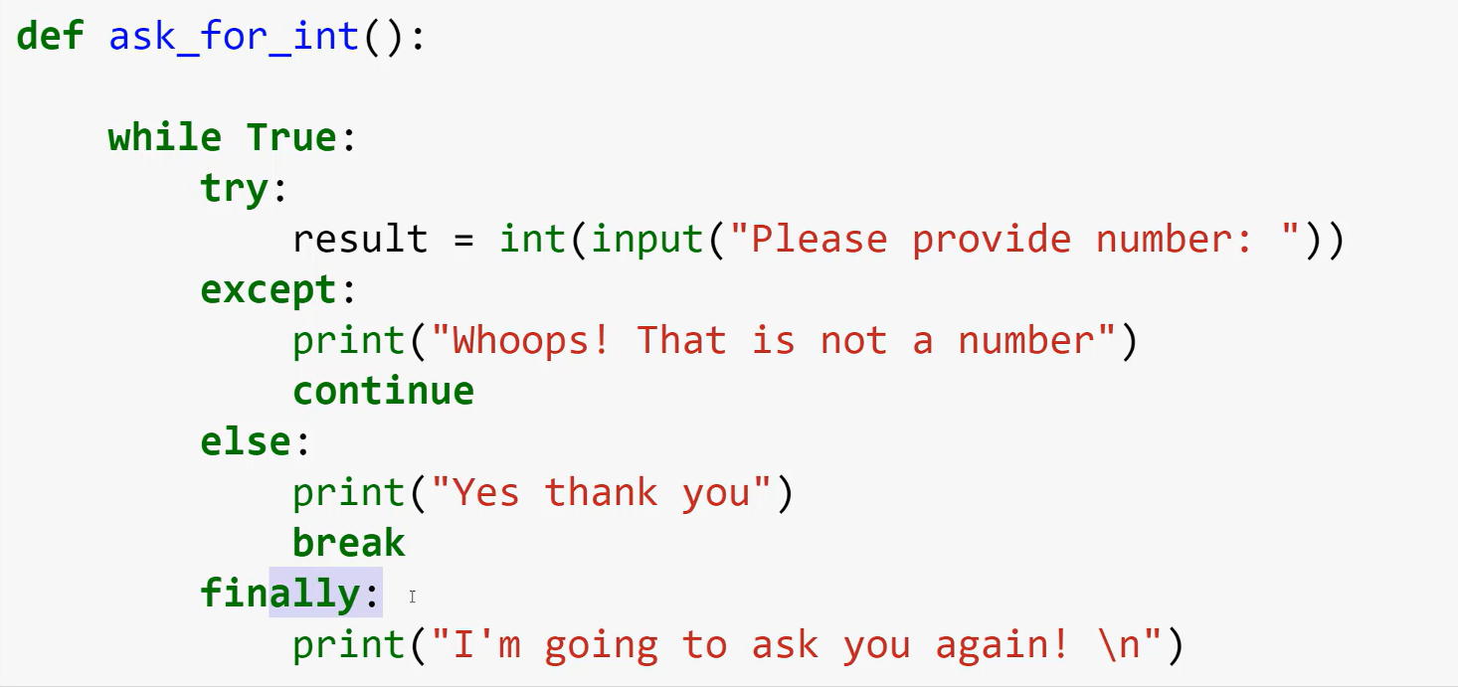

# Regular Expressions

A RegEx, or Regular Expression, is a sequence of characters that forms a search pattern. RegEx can be used to check if a string contains the specified search pattern. String Identifier, Character Identifiers. Group is used to get the returned string.

Import re

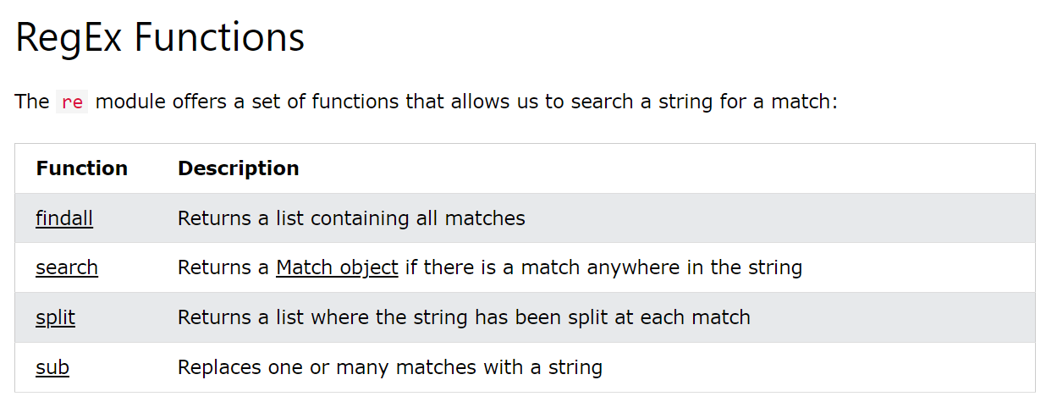

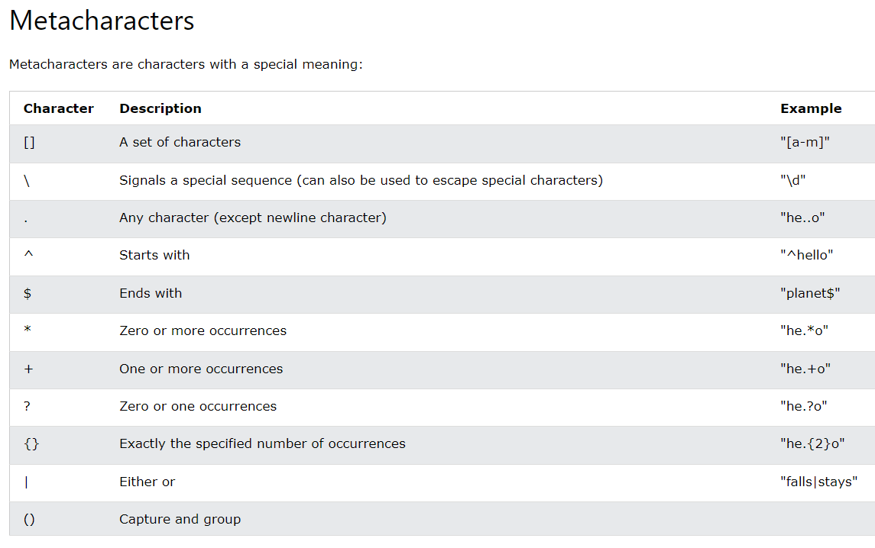

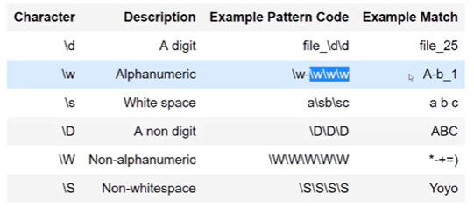

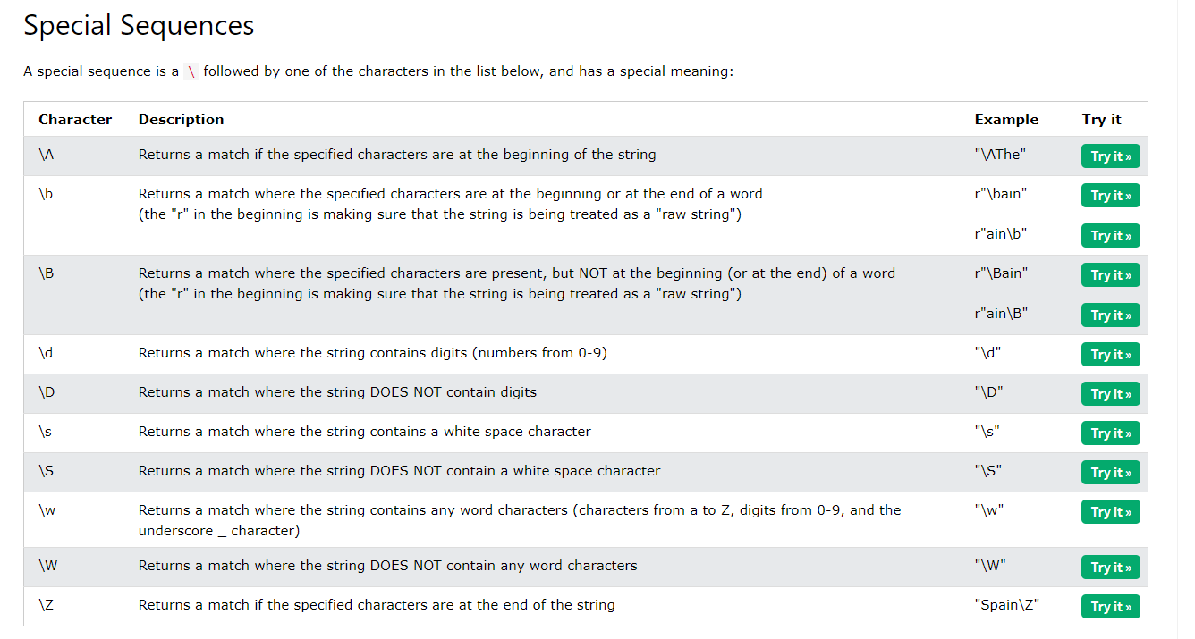

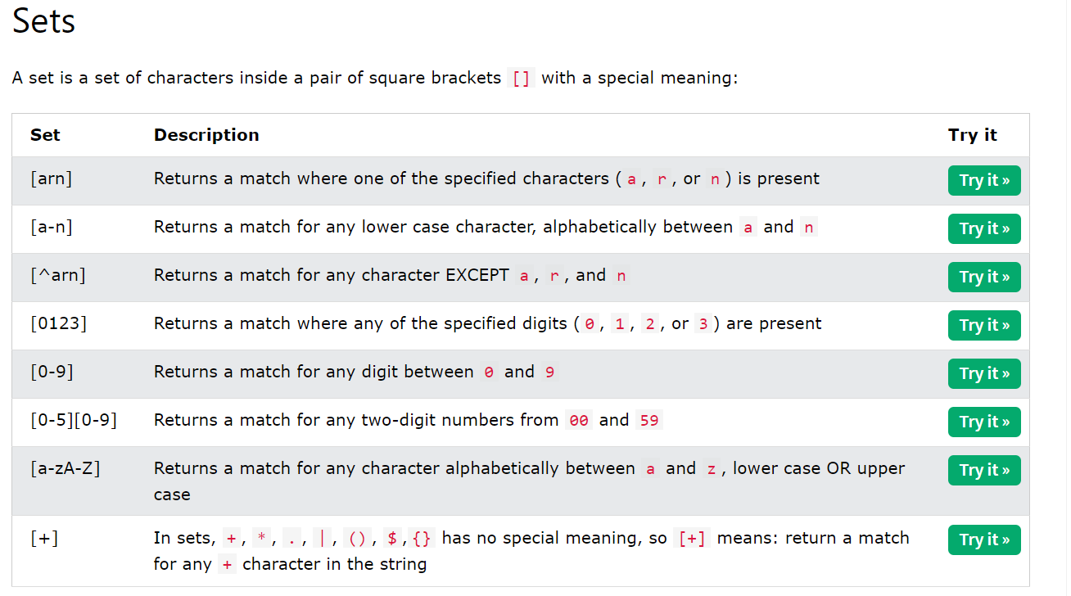

When the pattern is large

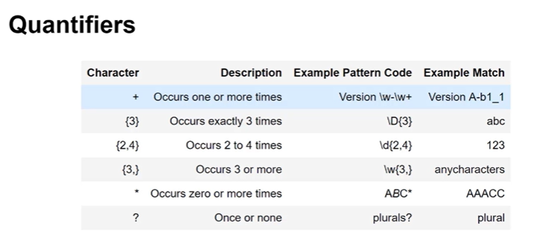

# Python Json

Import json

As in Java script we use fetch api to fetch the data from URL, In python the **request** package is used fetch the data from.

The data fetched from the server are in the form of json and the data we send to server must be in the form of Json format.

**To convert the data into object/ Dictionaries , json.loads(data)**

**To convert the data into Json format -> json.dumps(data)**

# Python Libraries:

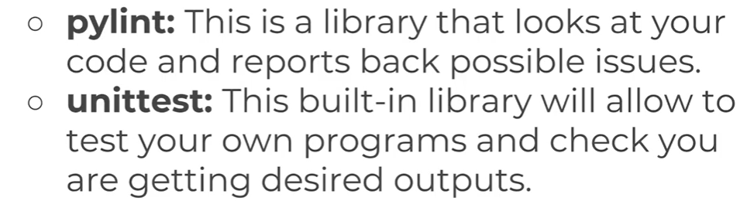

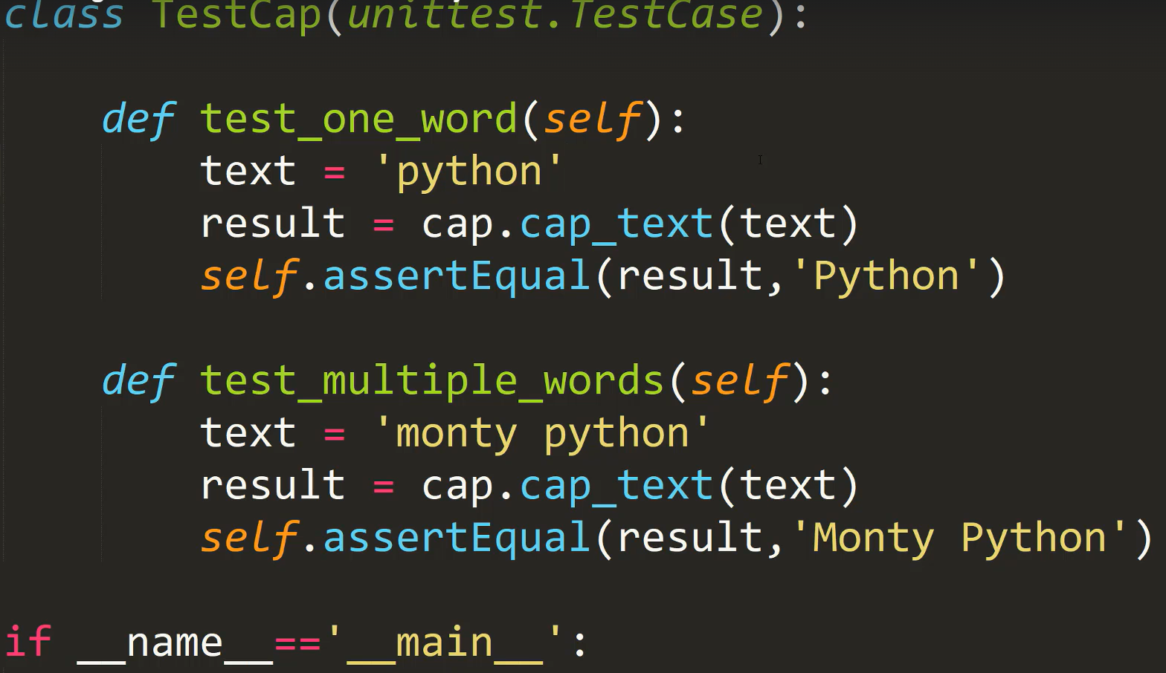

# Python Decorators

To Decorate Functions – Enhancing the functions with at annotation , a decorator is a function that takes another function and extends the behavior of the latter function without explicitly modifying it.

Decorators provide a simple syntax for calling [higher-order functions](http://en.wikipedia.org/wiki/Higher-order_function).

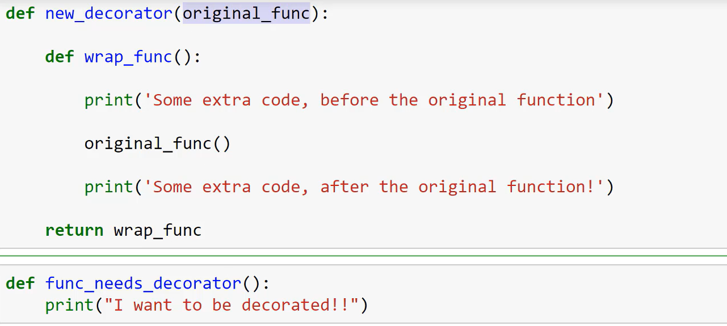

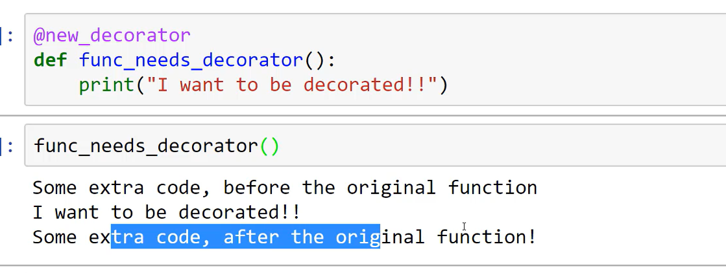

# **Generators in Python**

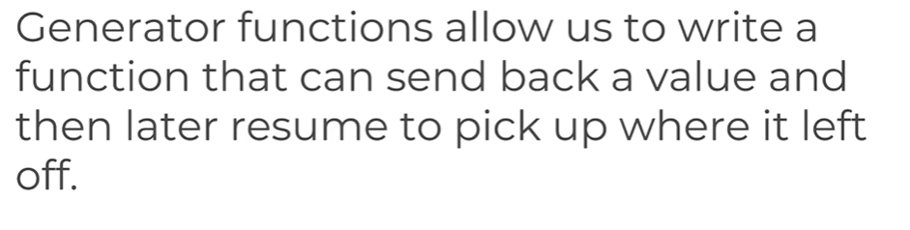

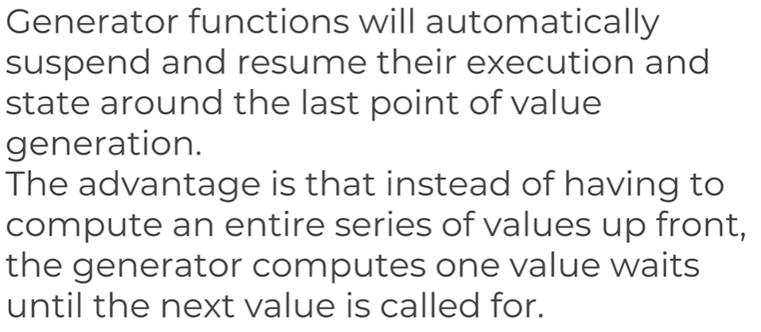

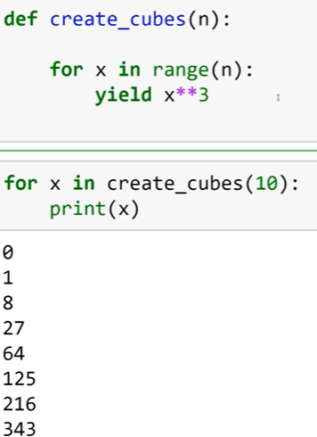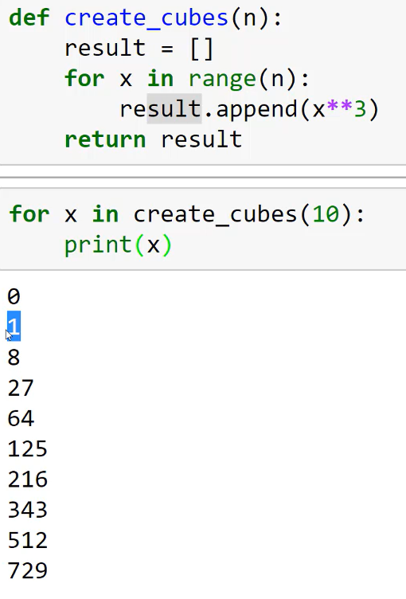

Python have inbuilt iter function to iterate through the object, it works as generator function , every element can be retrieved with next(attribute)

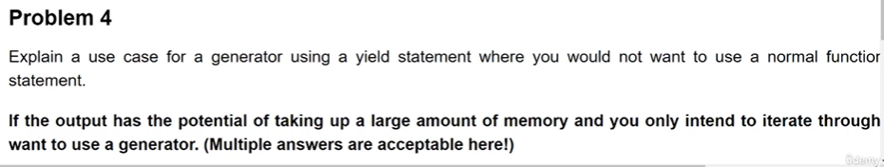

# **Collections in Python**

Counter to count the number occurrence of an element in list

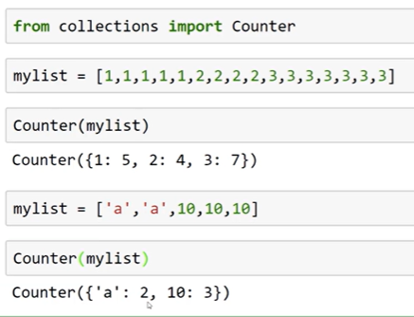

defaultdict() – the default value for any key if present or not is ZERO

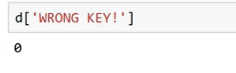

namedTuple – it has a ability to make tupple has dictionary

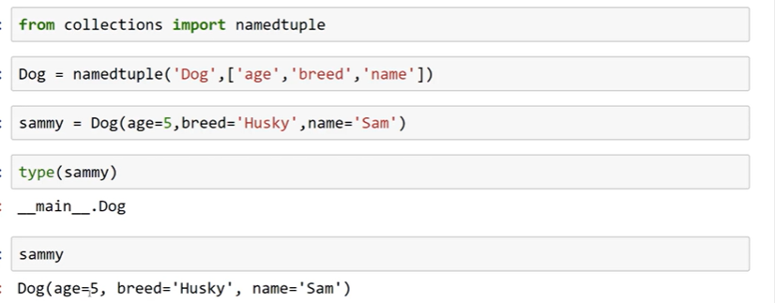

# **OS and Shutil packages in Python:**

OS offers-> os.getcwd, os.listdir(path)

for folders, sub_folders, files in os.walk(folder):

os.walk() – method offers to divide the path into folders, sub_folders, files .

os.getenv(“key”)

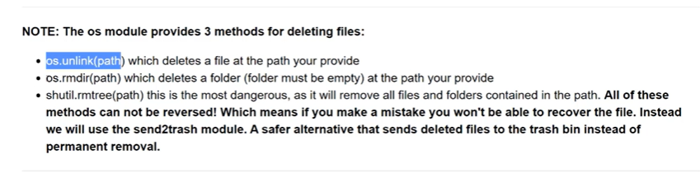

shutil is used move the files -> shutil.move(“sample file”, “target_path”)

using send2trash package file can be send to trash from python

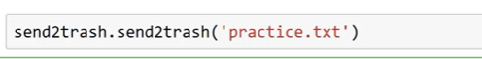

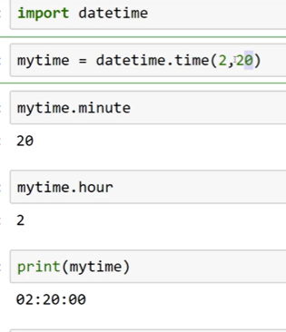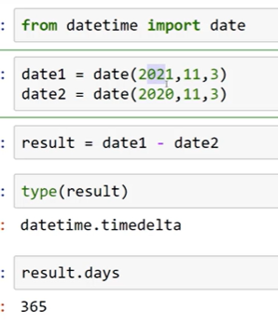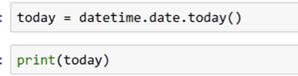

Math and random

# Zip and UnZip in Pyhton

Import zipfile

os.getcwd()

